
Machine Learning
Question 2


Priyanka Pravinkumar Sukre
April’20 Batch.
Contents
2.1 Find the number of characters, words, and sentences for the mentioned documents. 2
2.2 Remove all the stopwords from all three speeches. 3
2.3 Which word occurs the most number of times in his inaugural address for each president? Mention the top three words. (after removing the stopwords) 3
2.4 Plot the word cloud of each of the speeches of the variable. (after removing the stopwords) – 3 Marks 4

List of Figures:

S No | Figures | Description
1 | Fig 1.1 | Word Cloud for Roosevelt
2 | Fig 1.2 | Word Cloud for Kennedy
3 | Fig 1.3 | Word Cloud for Nixon

Problem 2:
In this particular project, we are going to work on the inaugural corpora from the nltk in Python. We will be looking at the following speeches of the Presidents of the United States of America:
- President Franklin D. Roosevelt in 1941
- President John F. Kennedy in 1961
- President Richard Nixon in 1973

2.1 Find the number of characters, words, and sentences for the mentioned documents.

After importing the code snippet in the given question the following are the analysis:
No.of Characters in the speech of Roosevelt: 7517
No.of Characters in the speech of Kennedy: 7618
No.of Characters in the speech of Nixon: 9991
No.of Words in the speech of Roosevelt: 1536
No.of Words in the speech of Kennedy: 1546
No.of Words in the speech of Nixon: 2028
No.of Sentences in the speech of Roosevelt: 68
No.of Sentences in the speech of Kennedy: 52
No.of Sentences in the speech of Nixon: 69

2.2 Remove all the stopwords from all three speeches.

The stop words along with the punctuation have been removed and after removing the count is as below:
No.of Words in the speech of Roosevelt: 695
No.of Words in the speech of Kennedy: 739
No.of Words in the speech of Nixon: 895

2.3 Which word occurs the most number of times in his inaugural address for each president? Mention the top three words. (after removing the stopwords)

A)Most Common Words in Roosevelt Speech are:
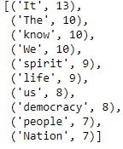
The top three words are “IT”, “THE”, ”Know”

B)Most Common Words in Kennedy Speech:
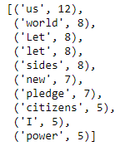
The top three words are “US”, “WORLD”, ”LET”

C)Most Common Words in Nixon Speech:
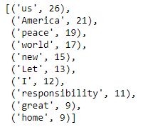

The top three words are “US”, “AMERICA”, ”PEACE”

2.4 Plot the word cloud of each of the speeches of the variable. (after removing the stopwords) – 3 Marks

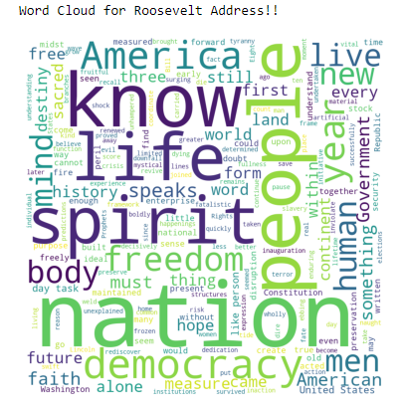
Fig 1.1 Word Cloud for Roosevelt
Roosevelt focuses on the spirit of American People.
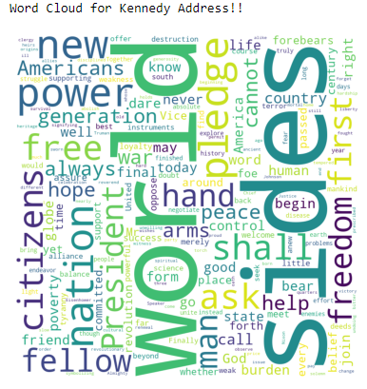
Fig 1.2 Word Cloud for Kennedy
Kennedy focuses Mostly on the word affairs unlike the Roosevelt and Nixon.

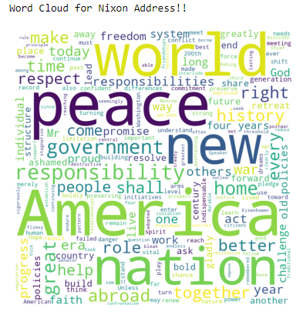
Fig 1.3 Word Cloud for NIXON
NIXON mainly focuses on the peace of world and also the America..!!

